# SQL ORDER BY Keyword

SELECT * FROM Customers ORDER BY Country;

SELECT * FROM Customer ORDER BY CustomerName ASC;

SELECT * FROM Customers ORDER BY Country DESC;

SELECT * FROM Customers ORDER BY Country, CustomerName;

SELECT * FROM Customers ORDER BY Country ASC, CustomerName DESC;

## SQL GROUP BY Statement

 GROUP BY statement groups rows that have the same values into summary rows, like "find the number of customers in each country".

The GROUP BY statement is often used with aggregate functions (COUNT, MAX, MIN, SUM, AVG) to group the result-set by one or more columns.

In the query, GROUP BY clause is placed after the WHERE clause.

In the query, GROUP BY clause is placed before ORDER BY clause if used any.

SELECT COUNT(CustomerID), Country FROM Customers

GROUP BY Country;

SELECT COUNT(CustomerID), Country FROM Customers GROUP BY Country ORDER BY COUNT(CustomerID) DESC;

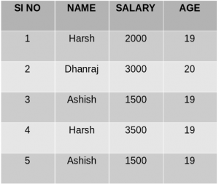

SELECT NAME, SUM(SALARY) FROM Employee GROUP BY NAME;

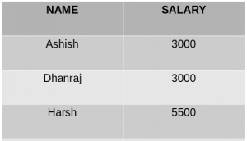

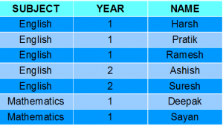

SELECT SUBJECT, YEAR, Count(*) FROM Student GROUP BY SUBJECT, YEAR;

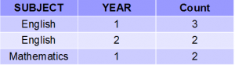

HAVING Clause

The HAVING clause was added to SQL because the WHERE keyword could not be used with aggregate functions.

SELECT NAME, SUM(SALARY) FROM Employee GROUP BY NAME HAVING SUM(SALARY)>3000;

Screenshot (56)

 lists the number of customers in each country. Only include countries with more than 5 customers:

SELECT COUNT(CustomerID), Country FROM Customers GROUP BY Country HAVING COUNT(CustomerID) > 5;

lists the number of customers in each country, sorted high to low (Only include countries with more than 5 customers):

SELECT COUNT(CustomerID), Country  
FROM Customers  
GROUP BY Country  
HAVING COUNT(CustomerID) > 5  
ORDER BY COUNT(CustomerID) DESC;